Assessment Schedule – 2015

Chemistry: Demonstrate understanding of bonding, structure, properties and energy changes (91164)
Evidence Statement
Q | Evidence |  |  |  |  | Achievement |  |  | Achievement with Merit |  | Achievement with Excellence
ONE  (a) | 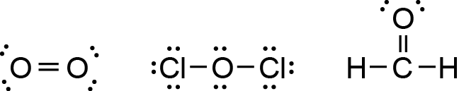 |  |  |  |  | - Two Lewis structures OR electron dot diagrams correct.
(b) | In each CCl₄ molecule, there are four negative / electron : densities / clouds / regions around the central C atom. These repel each other / are positioned as far away from each other as possible in a tetrahedral (base) arrangement, resulting in a 109.5º bond angle. All of these regions of electrons / electron densities are bonding, without any non-bonding regions, so the shape of the molecule is tetrahedral.  In each COCl₂ molecule, there are three negative / electron : densities / clouds / regions around the central C atom. These repel / are positioned as far away from each other as possible in a triangular / trigonal planar (base) shape, resulting in a 120° bond angle. All of these regions of electrons / electron densities are bonding, without any non-bonding regions, so the shape of the molecule is trigonal planar. |  |  |  |  | - One shape with matching bond angle correct.  OR  Correctly identifies the number of electron densities surrounding the central atom of one molecule.  OR  States that the shape of the molecule is determined by the repulsion between regions of electron density around the central atom. |  |  | - Links the shape of both molecules to the electron arrangement around the central atom.  OR  Links the bond angles in BOTH molecules to the electron arrangement around the central atom.  OR  Complete answer for CCl₄ or COCl₂. |  | - Evaluates the arrangement of electron densities around the central atom of BOTH molecules in order to correctly explain the shapes and bond angles.
(c) | Both molecules are non-polar.  The Be-Cl bond is polar because Cl is more electronegative than Be / the atoms have different electronegativities.  Since both the bonds are the same and arranged symmetrically around the central atom, in a linear arrangement, the bond dipoles cancel out, resulting in a non-polar molecule.  The B-F bond is polar because F is more electronegative than B / the atoms have different electronegativities. Since all three bonds are the same and arranged symmetrically around the central atom, in a trigonal planar arrangement, the bond dipoles cancel out, resulting in another non-polar molecule. |  |  |  |  | - Identifies electronegativity difference between atoms.  OR  Identifies the polarity of either the Be-Cl or B-F bond correctly.  OR  States that polarity of the molecule depends on the symmetry of the molecule. |  |  | - Non polar circled PLUS  Links the polarity of either Be-Cl or B-F bonds to the differences in electronegativity of the atoms involved.  OR  Links the even spread of polar bonds / bond dipoles around the central atom to their cancelling out and therefore to the overall non-polarity of the molecule. |  | - Justifies choice of polarity in terms of polarity of bonds, due to differences in electro negativities of the atoms, and the cancelling out of bond dipoles / polar bonds due to the symmetry and shape of each molecule.
(d) | C₂H₄(g) + Br₂(g) → C₂H₄Br₂(g)  Bonds broken Bonds formed  C=C 614 C–C 346  Br–Br 193 C–Br 2 × 285  807 916  Δ_{r}Hº = ΣBond energies(bonds broken) – ΣBond energies(bonds formed)  = 807 – 916 (or 2463 – 2572)  = –109 kJ mol⁻¹  (Alternative calculation that includes the breaking and reforming of four C-H bonds will also be accepted to Excellence level.) |  |  |  |  | - Correctly identifies the two relevant bonds broken, ie C=C and Br-Br, or formed, ie C–Br and C–C(qualitative)  OR  One step in the calculation correct.  OR  Correct answer with no working. |  |  | - Correct process for calculation with one error. |  | - Calculation correct with correct sign and units.
NØ |  | N1 | N2 | A3 | A4 |  | M5 | M6 |  | E7 |  | E8
No response or no relevant evidence. |  | 1a | 2a | 3a | 4a |  | 2m | 3m |  | 2e |  | 3e

Q | Evidence |  |  |  |  | Achievement |  |  | Achievement with Merit |  | Achievement with Excellence
TWO(a) | Exothermic because the temperature of the solution increases / heat is released / particles slow down / bonds are formed |  |  |  |  | - One of (a) or (b)(i) is correctly identified with reason.
(b)(i) | Endothermic because the Δ_{r}Hº value is positive / it uses the sun’s energy
(ii) | 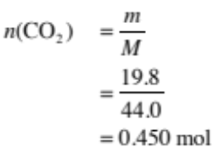  Since 6 moles of CO₂ reacting requires 2803 kJ of energy  then 1 mole of CO₂ reacting requires 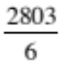 = 467.2 kJ of energy  and 0.450 moles of CO₂ requires 467.2 × 0.450 = 210 kJ of energy absorbed. |  |  |  |  | - One step of calculation is correct.  OR  Correct answer with no working. |  |  | - Two steps of the calculation for (b)(ii) are correct. |  | - Calculation for (b)(ii) is correct with correct sign and units.
(c)(i) | 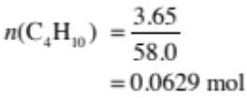  If 0.0629 moles of C₄H₁₀ releases 106 kJ of energy  Then 1 mole of C₄H₁₀ releases 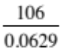 = 1685 kJ of energy  And 2 moles of C₄H₁₀ releases 1685 × 2 = 3370 kJ of energy (3368)  (Δ_{r}H = –3370 kJ mol^{–1}) |  |  |  |  | - One step of calculation is correct.  OR  Correct answer with no working. |  |  | - Two steps of the calculation for (c)(i) are correct. |  | - Calculation for (c)(i) is correct with correct sign and units.
(ii) | The results from this experiment are less than the accepted results, due to errors in the experimental design.  The errors could include:  - Some energy is used to heat the metal can and the air surrounding the experiment / the experiment was not conducted in a closed system  - Incomplete combustion of butane.  - Some butane may have escaped before being ignited.  - The butane in the gas canister was impure.  - Some water evaporated  - Some energy was converted to light and sound  - Not carried out under standard conditions  Therefore, not all of the energy released by the combustion of butane was transferred to heating the water. |  |  |  |  | - Identifies an error.  For example a user error, eg thermometer inaccurate.  Measured water (volume) inaccurately.  Scales inaccurate, for weighing butane canister. |  |  | - Links a potential error in the experimental design, to why the actual results from the experiment were different to the accepted results. |  | - Explains why the actual results from the experiment were less than the accepted results in relation to at least two experimental errors.
(iii) | 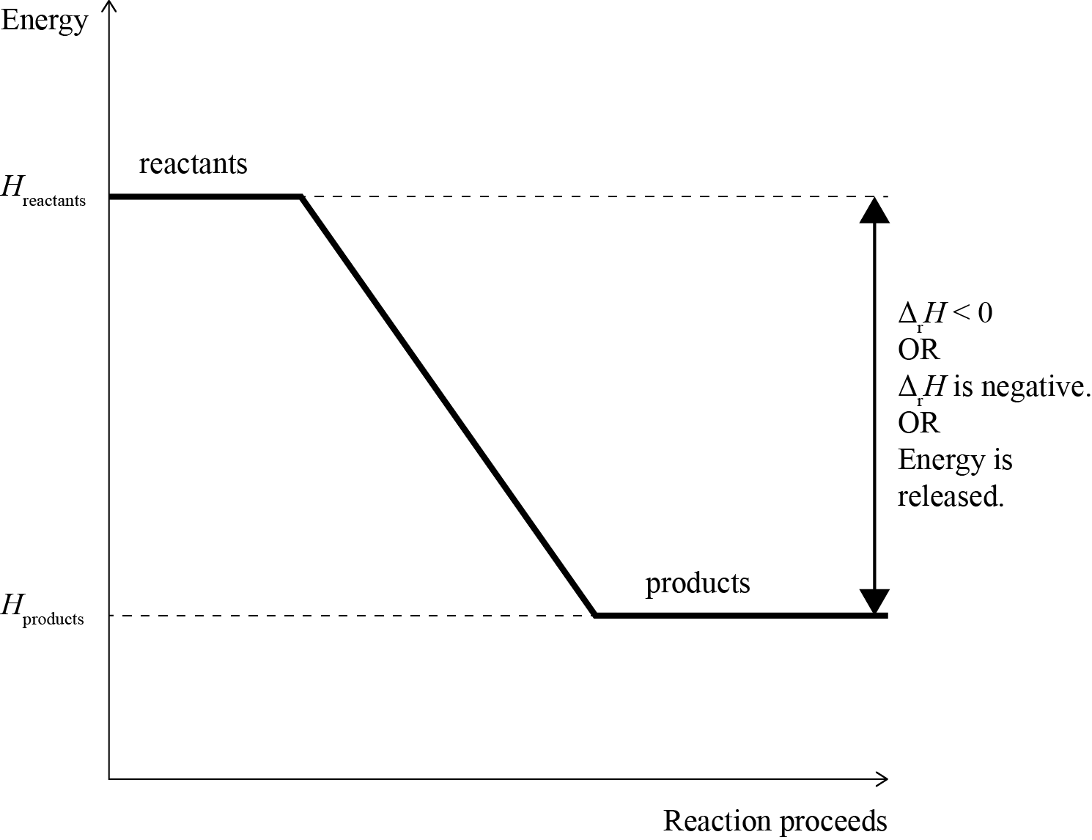 |  |  |  |  | - Diagram correctly drawn, but not labelled. |  |  | - Diagram correctly drawn and enthalpy change and reactants and products labelled correctly.  AND  Links overall enthalpy to bond-making releasing energy / being exothermic |  | - Diagram correctly drawn and enthalpy change and reactants and products labelled correctly.  AND  Links overall enthalpy to BOTH bond-making and bond-breaking correctly.
(iv) | When butane undergoes combustion, heat is released, so it is an exothermic reaction.  Bond-making is an exothermic process / releases energy and bond-breaking is endothermic / requires energy. For the overall reaction in the combustion of butane to release energy, more energy is given out as bonds are made (when the products, CO₂ and H₂O are formed) than the energy being used to break the bonds (in the reactants, C₄H₁₀ and O₂). |  |  |  |  | - Identifies bond-making as exothermic / releases energy  OR  Bond-breaking as endothermic / absorbs or requires energy  OR  Bonds formed are stronger than bonds broken
NØ |  | N1 | N2 | A3 | A4 |  | M5 | M6 |  | E7 |  | E8
No response or no relevant evidence |  | 1a | 2a | 3a | 4a |  | 3m | 4m |  | 2e, including one explanation from part (c) |  | 3e

Q | Evidence | Achievement | Achievement with Merit | Achievement with Excellence
THREE (a) |  | - One row or one column correct. | - Three rows or two columns correct.
  Substance | Type of Substance | Type of particle | Attractive forces between particles
  Cu(s) | metal / metallic | atom /  cation and delocalised electrons /  nuclei and electrons | metallic bond / electrostatic attraction between atom / cation / nuclei and electron
  PCl₃(s) | molecular | molecule | intermolecular (forces)
  SiO₂(s) | covalent network / giant covalent | atom | covalent bond
  KCl(s) | ionic | ion | ionic bond
(b) | Phosphorus trichloride, PCl₃, is a molecular solid, made up of non-metal phosphorus and chlorine atoms covalently bonded together. The molecules are held together by weak intermolecular forces. Since these forces are weak, not much energy is required to overcome them, resulting in low melting / boiling points. (In the case of PCl₃, its melting point is lower than, and its boiling point is higher than room temperature, so it is liquid.)  PCl₃ does not contain free moving ions nor any delocalised / free moving valence electrons, meaning PCl₃ does not contain any charged particles. Since free moving ions / electrons / charged particles are required to carry electrical current, PCl₃ is unable to conduct electricity. | - Reason given for one property of PCl₃. | - Links either state or conductivity to structure and bonding for PCl₃. | - Explanation links both state and conductivity to structure and bonding for PCl₃.

(c) | Cu is insoluble in water and malleable.  Copper is a metal made up of an array of atoms / ions / nuclei held together by non-directional forces between the positive nuclei of the atoms and the delocalised / free moving valence electrons. There is no attraction between the copper atoms and the (polar) water molecules, therefore Cu is insoluble in water.  Since the attractive forces are non-directional, when pressure is applied, the Cu atoms can move past each other to change shape without the bonds breaking, so Cu is malleable. (Note – labelled diagrams can provide replacement evidence).  KCl is soluble in water and not malleable.  KCl is made up of positive / K⁺ ions, and negative / Cl– ions, ionically bonded in a 3D lattice. When added to water, polar water molecules form electrostatic attractions with the K⁺ and Cl– ions. The partial negative charge, δ–, on oxygen atoms in water are attracted to the K⁺ ions and the partial positive, δ⁺, charges on the H’s in water are attracted to the Cl– ions, causing KCl to dissolve in water.  KCl is not malleable because if pressure is applied to an ionic lattice, it forces ions with the same charge next to each other; they repel each other and break the structure. (Note – labelled diagrams can provide replacement evidence).  SiO₂ is insoluble in water and not malleable.  SiO₂ is a covalent network made up of atoms covalently bonded together in a 3D lattice structure. (Covalent bonds are strong), Polar water molecules are not strong / insufficiently attracted to the Si and O atoms, therefore SiO₂ is insoluble in water.  SiO₂ is not malleable because if pressure is applied, the directional / strong covalent bonds have to be broken before the atoms can move.  (Note - labelled diagrams can provide replacement evidence). |  |  |  |  | - Table completely correct.  - Reason given for malleability for any substance.  - Reason given for solubility for any substance. |  |  | - Links ONE property for ONE substance to its particles, structure, and bonding.  - Links ONE property for A SECOND substance to its particles, structure, and bonding. |  | - Justification links BOTH properties for ONE substance to its particles, structure, and bonding.  - Justification links BOTH properties for A SECOND substance to its particles, structure, and bonding.
NØ |  | N1 | N2 | A3 | A4 |  | M5 | M6 |  | E7 |  | E8
No response or no relevant evidence |  | 1a | 2a | 3a | 4a |  | 3m | 4m |  | 2e |  | 3e
.

Cut Scores
Not Achieved | Achievement | Achievement with Merit | Achievement with Excellence
0 – 7 | 8 – 13 | 14 – 18 | 19 – 24

